**ESE-3014 Lab**

**Interfacing communication – Bluetooth**

**Task: Controlling LED strip (or at least one LED) via Bluetooth**

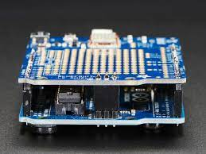

1. Connect your Adafruit BLE shield to the Arduino. Ensure pinout selection and soldering are fine. You might use the following reference for this purpose:

[Overview | Adafruit Bluefruit LE Shield | Adafruit Learning System](https://learn.adafruit.com/adafruit-bluefruit-le-shield/overview)

1. Connect an LED strip or at least one LED to the board
2. Use the code mentioned in the following reference. (If you just need one LED, how to modify the code?)

<https://www.dropbox.com/s/wp7v15m6nlf5kyw/Bluetooth%20controlled%20lights.rtf?dl=0>

1. Record the results!
2. You might watch the video with the following link for more information!

<https://www.youtube.com/watch?v=J2-ZFT1-vxI>